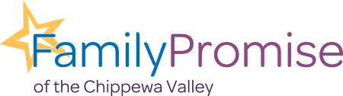

2020

ANNUAL REPORT

OUR MISSION:

Family Promise of the Chippewa Valley will advocate
for and support families who are homeless in our
community by providing temporary housing,
support services, and by fostering independence.

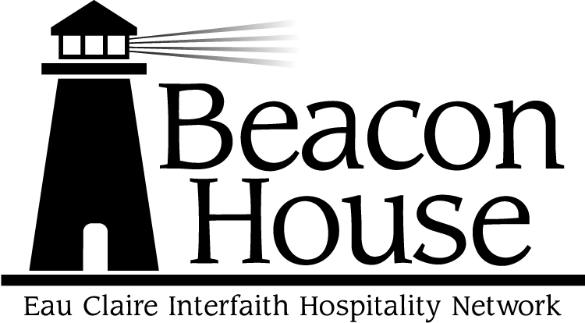

Introduction

2020 was the 19th year that the Beacon House was in operation. Although the pandemic has brought unforeseen challenges, with the help of dedicated staff and volunteers we were able to continue to serve families who are struggling with homelessness in the Chippewa Valley.

This year, we had to reduce our capacity to comply with COVID guidelines. Also, we changed from having overnight volunteers to now being staffed 24/7. We are hoping to safely bring volunteers back into our building soon.

Family Promise benefited from the generosity of the community amid the pandemic. We received financial contributions from individuals, organizations and businesses, as well as qualifying for additional grants in response to COVID. We also had numerous donations of essential shelter supplies, such as cleaning products, paper goods and pantry items. Additionally, we are very grateful for volunteers that gifted their time and resources to complete various projects, maintenance, and cleaning at both the shelter and our Transitional Housing Units.

Unfortunately, our annual HIKE for the Homeless event was cancelled this year due to the pandemic. However, we still received several donations from past supporters. We are looking forward to our 2021 HIKE, which will take place on Tuesday, August 17th.

Although our holiday program looked a little different this year, we still were able to provide gifts to many families in the Eau Claire area. We are very appreciative to Christ Church Cathedral for hosting this event and to the dedicated volunteers from Newman Parish and University Lutheran that made this program possible again this year.

We are thankful to all the volunteers, schools, churches, organizations, and businesses that supported FPCV this year! It is because of community support that we can continue to fulfill the mission of our organization.

2020 Board of Trustees
(December 31, 2020)

Katie Zook, President

Jennifer Brantner, Vice President
Tom Gillett, Treasurer
Ellen Higley, Secretary
Tom Hanko
Amy Ripley
Jennifer Holty
Kerry Hager
Jenny LaVick

2020 Staff
(December 31, 2020)

Amy Giani, Executive Director

Samantha Berg, Director of Development
Jackie Plant, Administrative Assistant
Elizabeth McNabb, Outreach Case Manager
Michelle Russell, Case Manager
Alexia Delleman, Shelter Worker
Ele Higley, Shelter Worker
Naomi Long, Shelter Worker
Hannah Schierenbeck, Shelter Worker
Lindsey Purrington, Shelter Worker
Michelle Hirsch, Shelter Worker

2020 Congregations

Christ Church Cathedral
First Congregational UCC
First Presbyterian
Good Shepherd
Grace Lutheran
Hope Lutheran
Hope United Methodist

Immaculate Conception
Immanuel Lutheran
Lake Street UMC

Newman Parish
Peace Lutheran
Sacred Heart of Jesus-St. Patrick’s
St. James the Greater
St. Olaf Catholic
Saving Grace Lutheran

Spirit Lutheran
Trinity Lutheran
Unitarian Universalist Congregation
University Lutheran

2020 Partners
Central WI Community Action Council, Inc.
Chippewa Valley Free Clinic
Chippewa Valley Street Ministry
Chippewa Valley Technical College
Community Table
Eau Claire Children’s Museum
Family Resource Center
Feed My People
Goodwill Industries
Hope Gospel Mission Bargain Center
Literacy Volunteers
McKinley Charter School
Paws & Claws
St. Francis Food Pantry
Salvation Army
Sojourner House
Stepping Stones Shelter - Menomonie
University of WI-Eau Claire and Stout
UW Extension
YMCA

Eau Claire Area School District
Eau Claire County-Dept. of Human Services Job Center
Eau Claire County Housing Authority
Eau Claire County Probation & Parole

City of Eau Claire Housing Authority
City/County Health Department
Career Development Center
Division of Vocational Rehabilitation WestCap
Western Dairyland, Economic Opportunity Council, Inc.
Workforce Resources
LSS Intensive in Home
LSS Positive Avenues
Aging and Disability Resource Center
Big Brothers Big Sisters
Bolton Refuge House
Boys & Girls Club
Catholic Charities
Care Wisconsin
King’s Closet

2020 Financial Support

United Way of Greater Chippewa Valley
FEMA-Emergency Food and Shelter Program
Housing and Urban Development (HUD)
City of Eau Claire
Eau Claire County
Eau Claire County Department of Human Services
Eau Claire Community Foundation
Together Chippewa Valley
Wisconsin Department of Administration:
Department of Energy, Housing, and Community Resources
Contributions:
Individuals, Corporate, Groups/Organizations and Churches

Community Programs

The agency offers a few programs that are open to the public including a small food pantry and a holiday toy distribution. Families do not need to be a past or present participant of our programs to engage in these programs. These programs are important to the community and rely upon many agencies, businesses and individuals to be successful.
During 2020

123 families received holiday gifts
181 bags of food were distributed

BEACON HOUSE SHELTER

With the incredible volunteer efforts of over 20 area faith-based organizations and groups, emergency shelter, meals, and hospitality are provided to families with children for up to 30 days. Extensions beyond 30 days are granted if families are working on their goals and need extra time. Families are accepted from all counties although priority is given to current county residents and those showing a strong intent to remain in the area.

During 2020

- 27 families received shelter (38 adults and 52 children)
- 3,807 nights of shelter were provided at Beacon House
- 2,800 volunteer hours were provided
- 11,288 meals were served
- 84 families were turned away
- 5 families received rental assistance/security deposits
- 50 vouchers for clothing at Goodwill and/or Hope Gospel Mission were given out
- 3 families received donated furniture after securing housing
- 2 educational info sessions provided at the Beacon House (paused due to COVID-19)
- Less than $100.00 was spent on food to feed 6 families,
three meals a day for the entire year thanks to our volunteers!!

2020 Targets and Outcomes

2020 Actual
70% of families will have stable housing after leaving Beacon House. 56%
70% of families will have stable employment/income after leaving Beacon House. 70%

Support Programs

Family Promise of the Chippewa Valley operates several support programs that assist families after they leave the Beacon House. These programs help families not only obtain but also maintain permanent housing. Programs include Transitional Housing, Rapid Rehousing, and Case Management.

During 2020

Transitional Housing: FPCV owns a duplex in Eau Claire. Two families at a time can reside in the unit. Families pay 30% of their income while the agency pays all of the expenses including utilities, maintenance, and insurance. This allows families that need some extra time to stabilize and frees up space at the Beacon House for other families needing shelter. Case management is provided.

- 3 families (9 adults and 18 children) received transitional housing through FPCV
- 2 Adults in 2 households maintained fulltime employment and received a promotion/pay increase during their stay in transitional housing.
- 1 family exited moved into subsidized permanent housing.
- 1 family acquired housing through a partnership with Pablo/Urban Living Homes
- 1 family had continuously maintained permanent housing for at least 6 months following exit from transitional housing.

Rapid Rehousing: The agency collaborated with Western Dairyland EOC to provide two rental assistance programs through the State and Federal governments. These two programs require that households pay 30% of their income and the program pays the balance for a specified period of time. Case management is provided to support families as they transition from homelessness to being housed to maintaining housing.

- 14 families (23 adults and 33 children) participated in the Rapid Rehousing program
- 5 households moved into other subsidized permanent housing.
- 2 households moved into permanent housing with no ongoing subsidy.
- 5 families were known to have maintained permanent housing for 3 months after move-in.
- 3 families were known to have maintained permanent housing for 6 months after move-in.
- 1 family is known to have maintained housing for 12 months after move-in.

2020 Targets and Outcomes

2020 Actual
60% of households remain in stable housing upon exiting a Support Program. 64%
60% of households will have stable income upon exiting a Support Program. 79%
70% of household in Transitional Housing will obtain permanent housing 100%

Our Vision

Family Promise of the Chippewa Valley, Inc.
envisions a day when every child has a place to call
home and an opportunity for a brighter future.

Family Promise of the Chippewa Valley, Inc.
309 E. Lake Street
Eau Claire, WI 54701
(715) 834-4357
FAX (715) 834-1886
agiani@familypromisecv.org
Amy L. Giani, Executive Director
www.familypromisecv.org

Income Statement 2020 (unaudited)

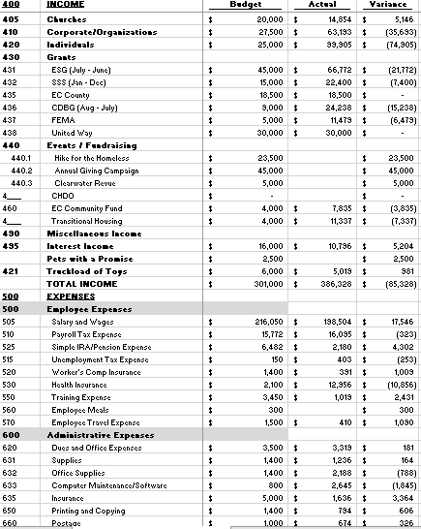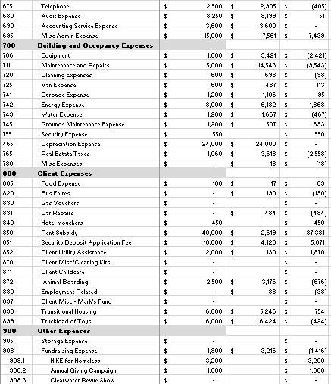
Balance Sheet as of December 31, 2020 (unaudited)

